**FRESH TEACHER'S E-LIBRARY**

**BEGINNING OF TERM III EXAMINATION 2023**

**PRIMARY THREE**

**READING**

**A**

**B**

**For Examiner’s**

**use only**

**TOTAL**

***Time Allowed: 2hours 15 minutes***

**Name: ______________________________________________**

**School: ______________________________________________**

**Class: _______________________________________________**

**SECTION A**

1. **Read these sounds (1mk)**

th o n c oo m bl ir f sh

1. **Red these words (2mks)**

Counselor destroy orphans mercy torture

Patient scientist continent health labour

1. **Read these sentences.**

1. Don’t eat food before washing hands. (**2mks @)**

2. Always cover pit latrines and toilets.

3. Are the children from different tribes?

4. Defilement and rape is a song every where.

5. Stop battering children.

6. I am preparing my garden for planting.

7. The sun provides light.

8. We can make mats from palm leaves.

9. Drums are made from hides and skins.

10. A word to wise is always enough.

1. **Read this poem (1mk @ word)**

Oh! Aids. The mention of you r name scares my skin.

Out of the darkness you crept in and swept our continent

Thousands and thousands you have killed.

Spoiled the beauty of our continent.

Causing no meaning to life.

Yet you are not satisfied.

Aids, do you have any mercy?

**Use the correct word in the brackets correctly.**

1. Mary always ____________________ over the rope. (jump)
2. John was ____________________ with us. (play)
3. Agnes ____________________ her tea in the morning. (take)
4. My mother ____________________ to church last Sunday. (go)
5. When ____________________Hellen wake up every day. (do)

**Fillin the blank spaces with the right word.**

1. A bird is to a nest as a ____________________is to a water.
2. A car is to a driver as a patient is to ____________________
3. A girl is to a boy as a man is to ____________________
4. Come is to ____________________as sit is to stand
5. Aunt is to ____________________ as brother is to sister.

**Arrange in ABC order.**

1. cup city cry can.

_______________________________________________________________________

1. eat rake cook mop.

_________________________________________________________________________

1. sweet swam swim sword.

_________________________________________________________________________

1. leg food gap kettle

________________________________________________________________________

1. cat desk ant book .

________________________________________________________________________

**Re-arrange these words to form meaningful sentences.**

1. tree cutting is a the man.

_________________________________________________________________________

1. is you father calling our.

_________________________________________________________________________

1. book where is my­?

________________________________________________________________________

1. holidays go will where for you?

_________________________________________________________________________

1. loves my teacher me.

________________________________________________________________________

**SECTION B**

1. **Read the poem and answer the questions about it in full sentences**

**A beggar man**

Beggar man beggar man

Why are you sad?

I have nothing to eat

And my head feels so bad

Beggar man beggar man

Come to my house

And you will have a delicious meal

**Questions**

* 1. What is the poem about?

_____________________________________________________________________

* 1. Why is the beggar man sad?

_____________________________________________________________________

* 1. Which meal will a beggar man have?

_____________________________________________________________________

* 1. The opposite of sad is

_____________________________________________________________________

* 1. Build is to builder as beg is to

_____________________________________________________________________

1. **Re-arrange these sentences to form a good story**

So I quickly ran to the shop

But the shop was closed

One day I was walking to school

To buy some chewing gum

I picked 200/= shillings

1. ………………………………………………………………………………………………

2………………………………………………………………………………………………

3. ………………………………………………………………………………………………

4………………………………………………………………………………………………

5………………………………………………………………………………………………

1. **Copy and write.**

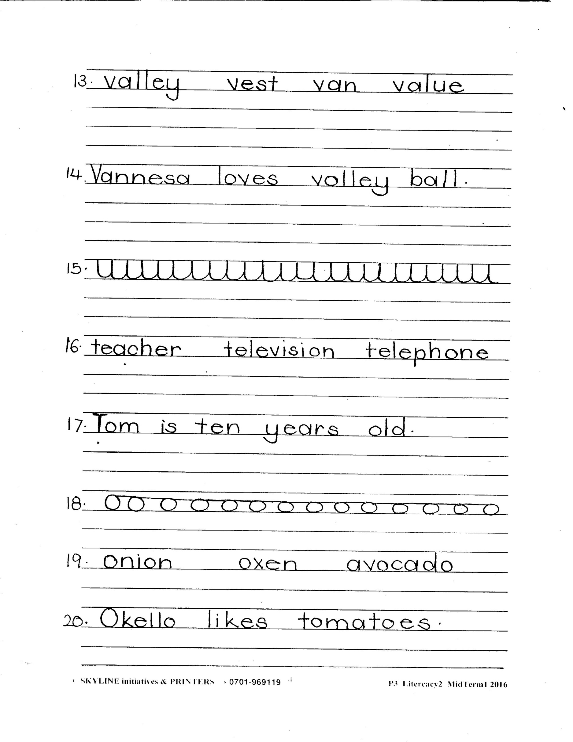

**END**